# **Name: Abdurrahman Qureshi**

# **Roll No: 210451**

Practical No: 4

**1)Execute and note down the output**

**OUTPUT:**

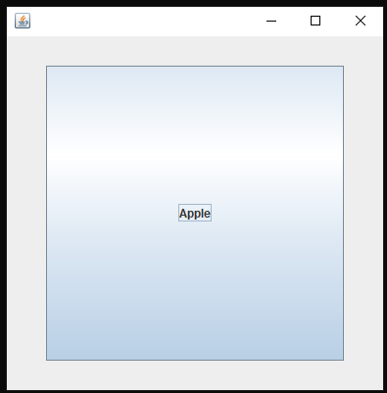 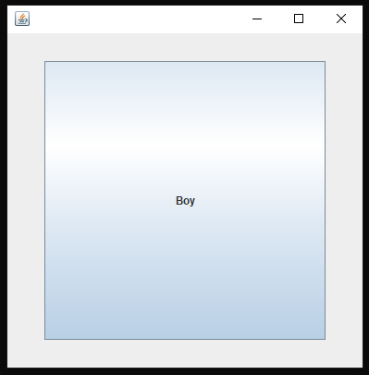 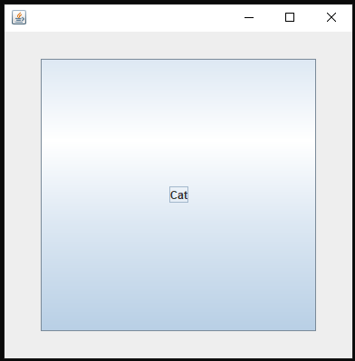

**2)Generate the following output**

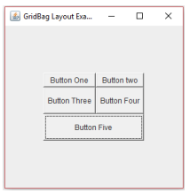

**CODE:**

import java.awt.*;

import java.awt.event.ActionEvent;

import java.awt.event.ActionListener;

public class Main extends Frame {

Main() {

Panel OuterBody = new Panel();

OuterBody.setLayout(new BorderLayout());

Panel MainBody = new Panel();

MainBody.setLayout(new GridLayout(3,2 , 10,10));

Panel A = new Panel();

A.setLayout(new GridLayout(1,2 , 10,10));

A.add(new Button("Button One"));

A.add(new Button("Button Two"));

Panel B = new Panel();

B.setLayout(new GridLayout(1,2,10,10));

B.add(new Button("Button Three"));

B.add(new Button("Button Four"));

Panel C = new Panel();

C.setLayout(new GridLayout(1,1));

C.add(new Button("Button Five"));

MainBody.add(A);

MainBody.add(B);

MainBody.add(C);

OuterBody.add(MainBody,BorderLayout.CENTER);

OuterBody.add(new Label(" "),BorderLayout.NORTH);

OuterBody.add(new Label(" "),BorderLayout.EAST);

OuterBody.add(new Label(" "),BorderLayout.WEST);

OuterBody.add(new Label(" "),BorderLayout.SOUTH);

add(OuterBody);

addWindowListener(new java.awt.event.WindowAdapter() {

public void windowClosing(java.awt.event.WindowEvent windowEvent) {

System.exit(0);

}

});

setFont(new Font("Comic Sans MS", Font.BOLD, 20));

setSize(500, 500);

setVisible(true);

setTitle("AJP Mixed Layout");

}

public static void main(String[] args) {

new Main();

}

}

**OUTPUT:**

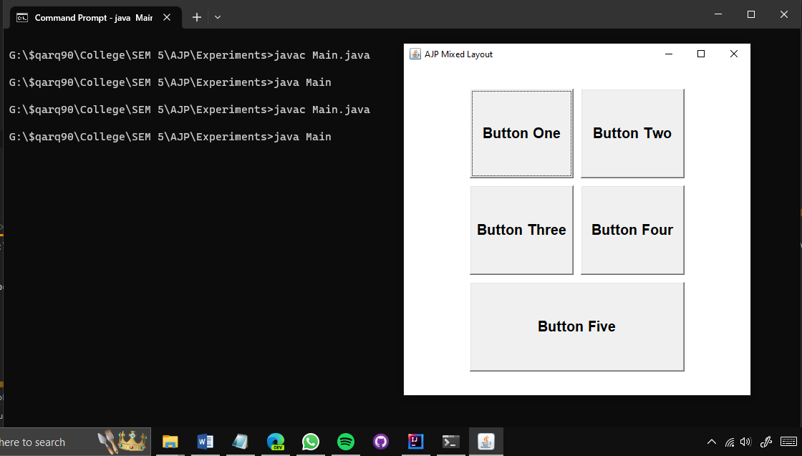

**3)Generate the following output**

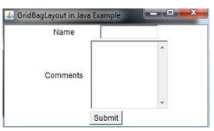

**CODE:**

import java.awt.*;

import java.awt.event.ActionEvent;

import java.awt.event.ActionListener;

public class Main extends Frame {

Main() {

Panel OuterBody = new Panel();

OuterBody.setLayout(new BorderLayout());

Panel MainBody = new Panel();

Panel A = new Panel();

A.add(new Label("Name"));

A.add(new TextField("Type here:"));

Panel B = new Panel();

B.add(new Label("Comments"));

B.add(new TextArea(5,10));

Panel C = new Panel();

C.add(new Button("Submit"));

MainBody.add(A);

MainBody.add(B);

MainBody.add(C);

OuterBody.add(MainBody,BorderLayout.CENTER);

OuterBody.add(new Label(" "),BorderLayout.NORTH);

OuterBody.add(new Label(" "),BorderLayout.EAST);

OuterBody.add(new Label(" "),BorderLayout.WEST);

OuterBody.add(new Label(" "),BorderLayout.SOUTH);

add(OuterBody);

addWindowListener(new java.awt.event.WindowAdapter() {

public void windowClosing(java.awt.event.WindowEvent windowEvent) {

System.exit(0);

}

});

setFont(new Font("Comic Sans MS", Font.BOLD, 20));

setSize(500, 500);

setVisible(true);

setTitle("AJP Mixed Layout");

}

public static void main(String[] args) {

new Main();

}

}

**OUTPUT:**

